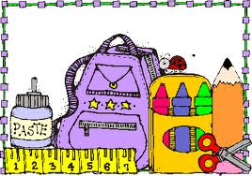
Mrs. Salazar’s Classroom Newsletter
Our Star Student is Noah!
Academic News
Math: We will use symbols to compare quantities, numbers, and we will add and subtract tens from a multiple of 10. We will also have a quiz!

Reading/Phonics: We will be reading an animal fantasy called Tippy-Toe Chick, Go! The phonics skill we will learn is the sound of ow/ow and syllables C+le! The comprehension skill we will practice is understanding character, setting, and plot. Our sight words are along, behind, eyes, never, pulling, and toward.

Science/Social Studies- We will be reading various science and social studies weekly readers.

Writing: We will be working on our ABC review journal!

Spelling Words

How, town, down, now, brown, cow, clown, frown, crowd, growl

